

Rambling Ram Newsletter
September 28, 2025

This week's issue includes:
- Featured Rams
- First Enrichment Day Fun
- Upcoming Events
- Parent/Teacher Organization Interest
- School Advisory Council Interest
- Scholarships and Contests
- Testing Reminders
- High School Elective Courses
- Student Spotlight Form
- SJVS Social Media

Featured Rams

Two full-time St. Johns Virtual students were honored by the Florida Department of Education for making perfect scores on a state test. One 9th grade student was honored with a perfect score on the Civics EOC while 11th grader, Carter Olmstead [pictured above] received a perfect score on the US History EOC. Congratulations on your achievement!

First Enrichment Day Fun

Last Friday, we hosted over 60 students full-time SJVS students on our campus for our Shark Enrichment Day. Two SJVS teachers received a Guy Harvey grant which provides professional development for teachers to return and share with students. The grant allowed the teachers to purchase preserved baby sharks for students to hold, measure, and learn about their structure. Other activities included painting fish and applying them to paper, reading a story about sharks, and learning about tagging sharks in the ocean.

Our next Enrichment Day will be October 24. Be on the lookout to sign up in an upcoming newsletter. Follow our social media channels to see more pictures from the Enrichment Day!

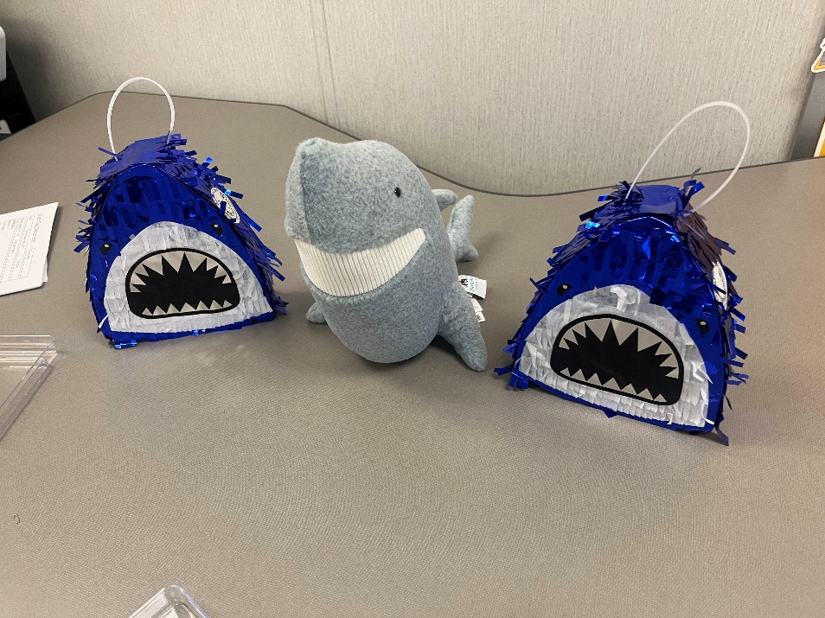

Upcoming Events

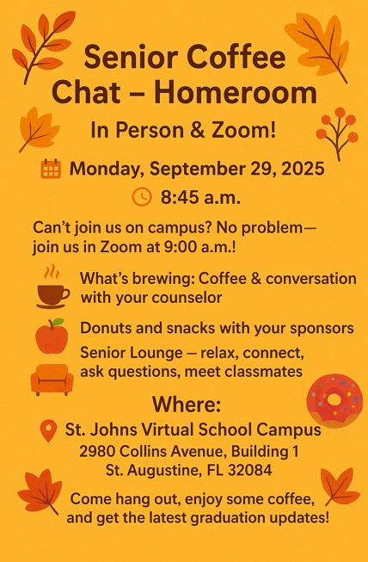

Mandatory Virtual Homeroom Tomorrow @ 9am
Full-Time St. Johns Virtual Students should attend their grade level's virtual Homeroom tomorrow at 9am. Students will be receiving state required instruction during Homeroom and will complete an attendance verification form at the conclusion. Please correspond with your student's Homeroom teacher if there is any reason they will be unable to attend.

Homeroom teachers are listed below. Students can access their Homeroom Zoom link by clicking on Homeroom on the Student Dashboard in their virtual account.

6th Grade-Ms. Williams/Ms. Harris
7th Grade-Ms. Urbizu/Ms. Santinho
8th Grade-Ms. Fisler/Ms. Sikes
9th Grade-Ms. McCullough/Ms. Lemons
10th Grade-Ms. Wilkie
11th Grade-Ms. King/Mr. Villavisanis
12th Grade-In person with Ms. Guttinger/Ms. McElhone or virtually with Mr. Vasiliades

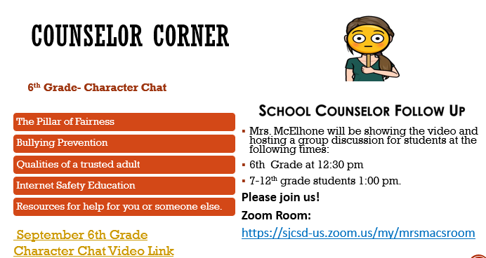

Character Chats Discussions Tomorrow
Our school counselor Ms. McElhone will have an optional discussion time for 6th grade students at 12:30pm and a discussion time for 7th-12th grade students at 1:00pm tomorrow in her Zoom Room about the district Character Chats videos.

This is an opportunity to further discuss the topics listed above that are part of the monthly state required instruction talk in Homeroom tomorrow.

Parents are encouraged to view these district videos with their children!
6th Grade Character Chat Video Link
7th-12th Grade Character Chat Video Link

Talking with your school counselor is a great way for her to get to know you better for award nominations, support, and letters of recommendation in high school!

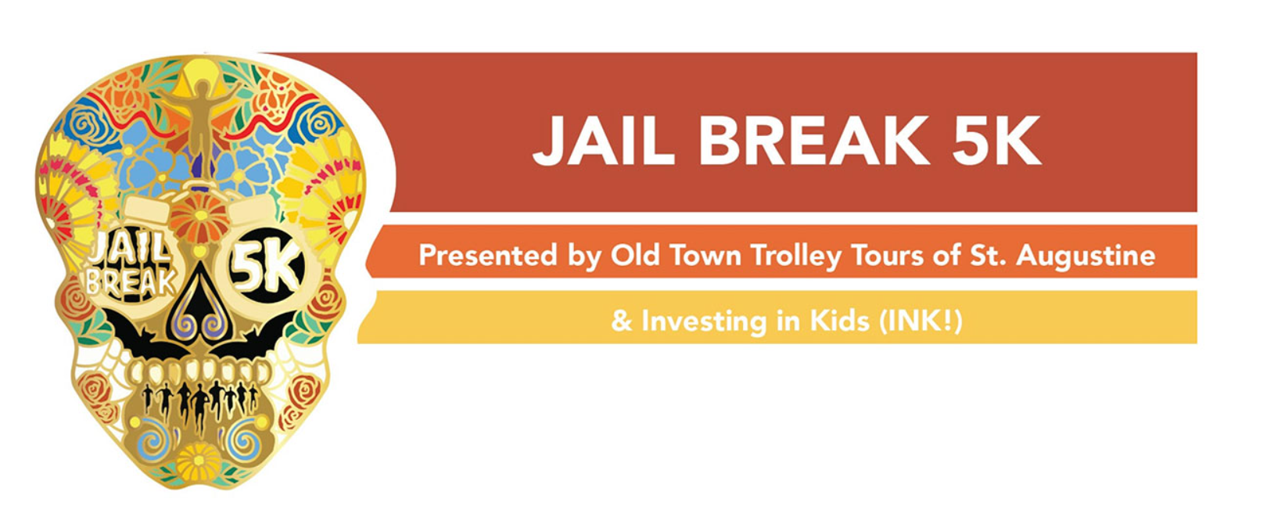

Register Today for the INK! Jail Break 5k
Escape the ordinary and race for a reason at the Jail Break 5K! Starting at the historic Old Jail in St. Augustine, runners and walkers will make their “getaway” along a scenic route toward the beach — all to support Investing in Kids (INK!) and public education in St. Johns County. Find more race info here.

Whether you’re chasing a personal record or just here for the fun, every step you take helps fund programs for local students and teachers. Costumes, camaraderie, and community spirit encouraged!

When: Saturday, October 25, 2025 – 8:00 AM Race Start
Where: Old Jail, St. Augustine, FL
Why: 100% of proceeds benefit programs supporting St. Johns County public school students & educators.

Be sure to register with the SJVS team here! The public school with the highest number of registered participants will receive a one-of-a kind Jail Break 5K Team Challenge trophy, bragging rights, and a $1,000 award! Prize money will also be awarded to the 2nd and 3rd place public school teams registering the 2nd and 3rd highest number of event participants.

Dr. Page will be joining walkers in the race!

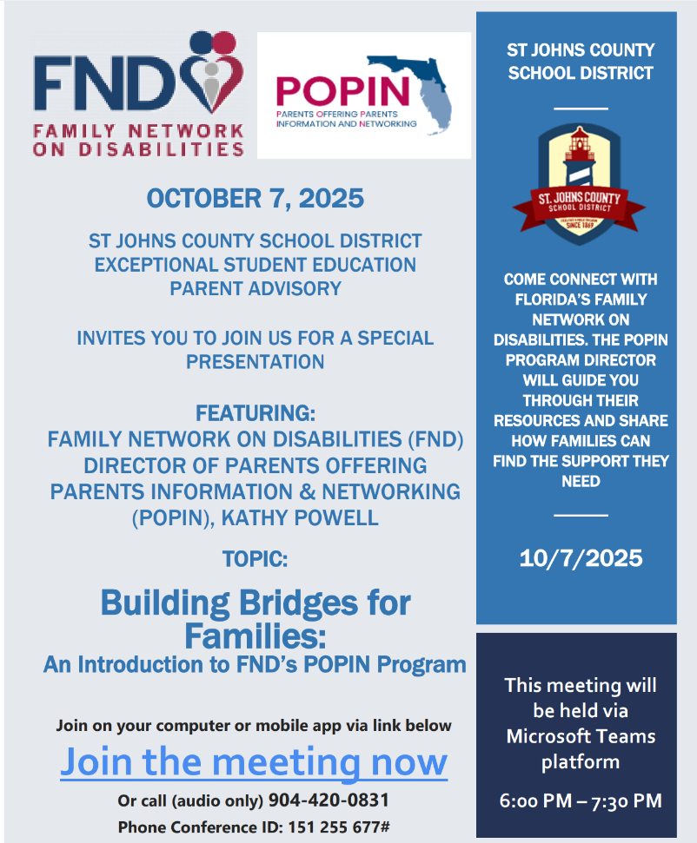

Quarterly Virtual ESE Parent Meeting Oct. 7 @ 6pm
The first quarterly virtual ESE parent meeting for the 2025/2026 school year is scheduled at 6:00 pm on October 7th.

Topic: Building Bridges for Families: An Introduction to FND’s POPIN Program
Presenter: Family Network on Disabilities (FND) Director of Parents Offering Parents Information & Networking (POPIN), Kathy Powell
Date/Time: 10/7/2025 from 6:00 pm – 7:30 pm
Description: Come connect with Florida’s Family Network on Disabilities (FND). The Parents Offering Parents Information & Networking (POPIN) Program Director will guide you through their resources and share how families can find the support they need. Join on your computer or mobile app via link below.

Join the meeting now
Or call in (audio only) 904-420-0831
Phone Conference ID: 151 255 677#

Avery Greene, ESE Coordinator, Support Services

Parent/Teacher Organization (PTO) Interest
In order to establish a PTO, there must be a minimum of three parents who would serve in officer positions creating a 501(c)(3) Non-Profit. We have a former PTO president from another school in district who can help with advising in setting up a PTO if anyone is interested but unsure of where to start.

PTO differs from SAC in that it is a separate entity not managed by the school and PTO can use funds raised with less restrictions than what SAC funds can be used for. If you are interested, please complete this form.

School Advisory Council (SAC) Interest
Complete this interest form to be part of the team that reviews our school improvement plan, how to spend certain funds, and reviews school data. Monthly meetings are virtual and held at 6:00pm on Tuesdays (see schedule to the left).

We are still looking for parents, students, and business partners to join SAC!

Scholarships and Contests

New Worlds Reading Elementary Scholarship Program
The New Worlds Reading program provides free books to Florida students in grades K-5. Click here to see if your student qualifies for this wonderful opportunity.

Patriot's Pen Essay Contest for 6th-8th Graders
Click here to read more about this essay contest.

Voice of Democracy Audio Essay Contest for 9th-12th Graders
Click here to read more about this contest.

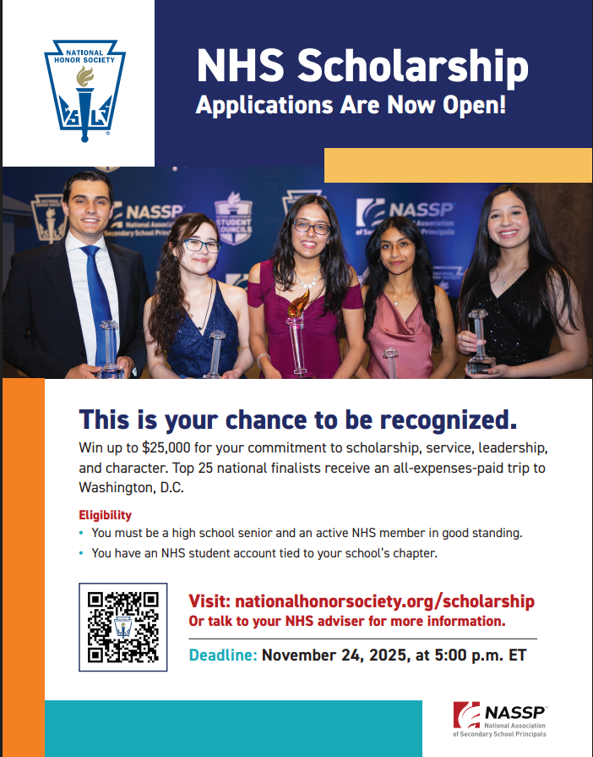

National Honor Society Scholarship
Attention: No National Honor Society students from SJVS have applied. Millions of scholarship dollars go unused annually, reducing the incentive for organizations to continue offering them. Please apply today!

Since 1946, the National Association of Secondary School Principals (NASSP) has awarded more than $30 million in scholarships to outstanding NHS seniors. This year, we are awarding $2 million in scholarships to 600 students. Each year, scholarship recipients are selected based on their demonstration of the four pillars of NHS: Scholarship, Service, Leadership, and Character.

Find the scholarship resource guide here and application here.

Timeline
- September 8, 2025: Application opens
- November 24, 2025 at 5:00 p.m. (ET): Submission deadline
- February 2026: Applicants receive notifications
- April 2026: All-expense paid trip to DC for top 25 scholarship finalists and their advisers

Eligibility
To be eligible, a student must be:
- A high school senior and/or expecting to receive a high school diploma during the current academic year.
- An active member in good standing of a National Honor Society chapter, meeting all membership requirements and obligations of the local chapter.
- An NHS student account holder, verified by the NHS chapter adviser.
- Planning to pursue a degree at an accredited U.S. college or university.
Note: There are no limits to the number of applicants per chapter.

Contact SJVS National Honor Society Sponsor Ms. Williams for more information!

Testing Updates

Upcoming Test Dates
Mandatory Progress Monitoring (PM 2) Testing for St. Johns Virtual Full Time students will begin in December. Please see test dates below and on our school testing website.

¬Dec 2-Grades 6-7 Reading
¬Dec 4-Grades 8-9 Reading
¬Dec 5-Grade 10 Reading (Graduation Requirement)
¬Dec 9-Grades 6-8 Math
¬Dec 11-FL Civic Literacy Exam (Students taking US Government only)
¬Dec 12 Biology/Civics/US History EOC Retakes & Makeups
¬Dec 16-Grade 10 Reading Retakes (Graduation Requirement)
¬Dec 18-Alg 1 EOC Retakes (Graduation Requirement)

Front office staff will begin admitting students at Bldg 1 (2980 Collins Ave, St. Augustine, FL 32084) for testing no earlier than 9:00am. Students should report for testing no later than 9:15am. Testing starts promptly at 9:30am. Please be mindful if you call the morning of testing that staff are setting up and directing students to test locations and may not return your call until the afternoon when testing is over.

Makeup Testing
All Full-Time St. Johns Virtual students are required to participate in state testing. If your child missed their test date, contact Ms. Thornton to confirm their attendance at makeup testing.

High School Elective Options
If you are interested in taking either elective course below and are:

- a Full-Time SJVS student, contact your school counselor Ms. McElhone.
- Students who attend brick-and-mortar schools full-time can register through their zoned school's high school counselor.
- Home Ed students' parents can request and approve the course in their virtual account.



Social Media

We are on multiple platforms, be sure to follow us for all the latest information!

Instagram: Follow us @st_johns_virtual_school
Facebook: Follow us @St. Johns Virtual School
X: Follow us @SJVS_GoRams
YouTube

